**Project Logo and Tagline**

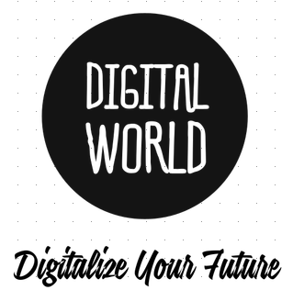

**Name:** Digital World Prvt ltd

**Vision:** As a top-tier employer, Digital World Limited promotes employee ownership, leadership, professional fulfilment, and job satisfaction. We deliver profitability and business success to our global clients through precise execution and technical excellence.

**Mission:** Digital world’s limited aspires to enhance the productivity and growth of organizations around the world with a comprehensive range of digital solutions and services.

**Swot Analysis**

**S 🡪** Strength **O 🡪** Opportunities

**W 🡪** Weaknesses **T 🡪** Threat

**Internal Strength 🡪** Revenue Generation, Intellectual Resources, Freelancing, out sourcing & insourcing, Most Products & Services

**External Strengths 🡪**  Digitalize Health Care & Education Sector’s, Bringing investment in country, Support from Government & I.T Ministries

**Internal Weaknesses 🡪** Lack of skilled persons, Lack of training

**External Weaknesses 🡪** Strict Regulations, Pakistan’s safety situation to avoid client to invests

**Opportunities 🡪** Excel and achieve global recognition, Work with best developers around the country

**Threats 🡪** Cyber Attacks, Cracking/Hacking, Viruses , Data hijacked

**Products and Services we offered**

We are providing top-notch products and reliable services in the global software marketplace. We don’t do a lot of things, but whatever we do, we do it in style and according to the highest standards of software engineering. With a focus on specific state-of-the-art technologies, we only deliver products and services in the following market segments of the software industry:

1. Web Application Development: HTML, CSS, JavaScript, Type-Script, React, Angular 2, Node.js, MongoDB, Firebase, and Server-less Architecture.
2. Android App Development using Java
3. iPhone (iOS) App Development using Swift
4. AI, Machine Learning(ML) and Deep Learning using Python
5. Software Defined Networks (SDN) using Python
6. Fin-Tech Research and Development using Python
7. UI/UX Design

We, at Digital World, believe that software developers are the most valuable resources of the world in this digital age - even more valuable than oil wells or gold mines. We think that App creation process starts with developer’s selection and training, not when we start working on a particular application. Given these beliefs, we have developed a unique business model that focuses on selecting top students and professionals and then training them completely free of charge to be world-class developers in selected cutting-edge technologies. As a result, we are able to train and retain a large number of developers every year in the latest state-of-the-art technologies specifically needed to deliver products and services to the above-mentioned target market segments

**What would be the pricing strategy and Why: how would you calculate the break even. Provide justification of your pricing strategy**

**Pricing Strategies for Digital Products**

* **Know the market, and price competitively 🡪** Complete a competitive analysis and assessment so that you know how others in the industry are pricing similar digital products. Then, price yours to position it against the competition. If your product offers exclusivity, bonus content or a value-add that competitors’ products do not include, consider pricing that's slightly higher or at least leverage the value-adds in your marketing messages. If your competitors offer similar products, consider how you can discount or incentivize with price without sacrificing your profit margins.
* **Offer a money-back guarantee 🡪** Money-back guarantees take away the last objection to purchasing a digital subscription by removing the risk in the transaction. Customers leery of buying from an unknown or independent digital provider may be less cautious if they are certain their money is not at risk. If you offer a quality product, you should see few, if any, returns. And if you aren’t certain about the quality of your product, take it back to the drawing board for additional tweaks; don’t release it!
* **Let customer try before they buy 🡪** Nearly every company offers customers to try before buy. Most companies offer a 7-day, 21-day or 30-day free trial. Be sure to have an auto responder in place that will automatically contact customers whose free trials are expiring to remind them to renew before the trial ends. Consider adding a special offer to those who do renew before the trial ends to make it easy for customers to say "yes" and buy the full subscription package.
* **Offer an added bonus 🡪** Everyone loves a free gift with a purchase. That’s why many digital products, such as e-books, add a free e-book or give an added feature in your software to your purchase. It’s an added, perceived value that can convince uncertain customers to complete the transaction. If you do offer an added bonus, be sure it adds substantial value to your core offering.
* **Test your offer and price and be creative 🡪** Pricing is important, but so too are the elements around the price on your website. The offer and creative elements work with pricing to attract customers to the page and convert browsers into buyers. Test different price points, new creative methods to showcase features and benefits of your products, new calls to action and added value or bonus products to see which combination converts the most leads to sales.

**What would the promotional strategies**

## Promotional Strategies

## By Social Media Promotion 🡪 We promote our products by social media websites such as Facebook, Youtube and Google+ offers a way to promote products and services in a more relaxed environment. Due to social media marketing we are not restricted to only one country. Millions of users can view our product and engage with us.

## By Branded Promotional Gifts 🡪 Giving away functional branded gifts can be a more effective promotional move than handing out simple business cards. Putting business card on a magnet, ink pen or key chain. These are gifts we give our customers that they may use, which keeps our business in plain sight rather than in the trash or in a drawer with other business cards the customer may not look at.

## Product Giveaways and Samples 🡪 Product giveaways and allowing potential customers to sample a product are methods used often by companies to introduce new food and household products. Many of these companies sponsor in-store promotions, giving away product samples to entice the buying public into trying new products.

## Causes and Charity 🡪 Promoting your products while supporting a cause can be an effective promotional strategy. Giving customers a sense of being a part of something larger simply by using products they might use anyway creates a win/win situation. You get the customers and the socially conscious image; customers get a product they can use and the sense of helping a cause. One way to do this is to give a percentage of product profit to the cause your company has committed to helping.

## Mail Order Marketing 🡪 Customers who come into your business are not to be overlooked as they have already decided to purchase your product. What can be helpful is getting personal information from these customers. Offer a free product or service in exchange for the information. These are customers who are already familiar with your company and represent the target audience you want to market your new products to.

**What would be the distribution, how it would reach to its consumers**

**Product Distribution 🡪** There is a completely different scenario of our product distribution because in our case our product is totally digital. There is only a gap of one click between us and our customer. There is completely digital distribution of our product to our customer. The scenario is totally same even if a customer is thousand miles away from us or he is located in the next street we distribute our product digitally. We build our product digitally and we deliver our product digitally. Our customer receives their product on a text message. He doesn’t wait for hours or days or even months to get their product. He receives his product in any condition for example if he is in business meeting or any other circumstances.

**Our interactivity with client 🡪** Our client has to go our website then he choose the product and select the packages we offer like if our client is interested in developing their E-commerse website then get into web-application development section after placing their order we receive a message through e-mail and our developers start making that website and their message displays on the website that your website complete in 4 days and also our management staff were in contacting with the client during those days and once clients website is ready we send all important information to client through e-mail and client just need to put that information on the specific server and that’s it

**Discuss what strategy you will adopt to enhance the product life cycle of your product or service**

Our software products were developed under highly skilled software developers and engineers. These softwares are developed in SDLC environment means **(SOFTWARE DEVELOPMENT LIFE CYCLE)**. It consists of seven steps as you see below towards diagram:

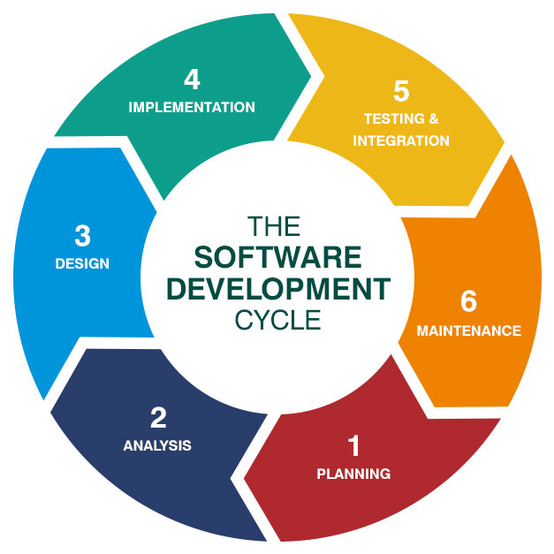

Whenever a software is cleared from these 6 steps then we start working on their development. After completing it’s development then our Quality Assurance Engineer ensures its quality and then we delivered our product to our client.

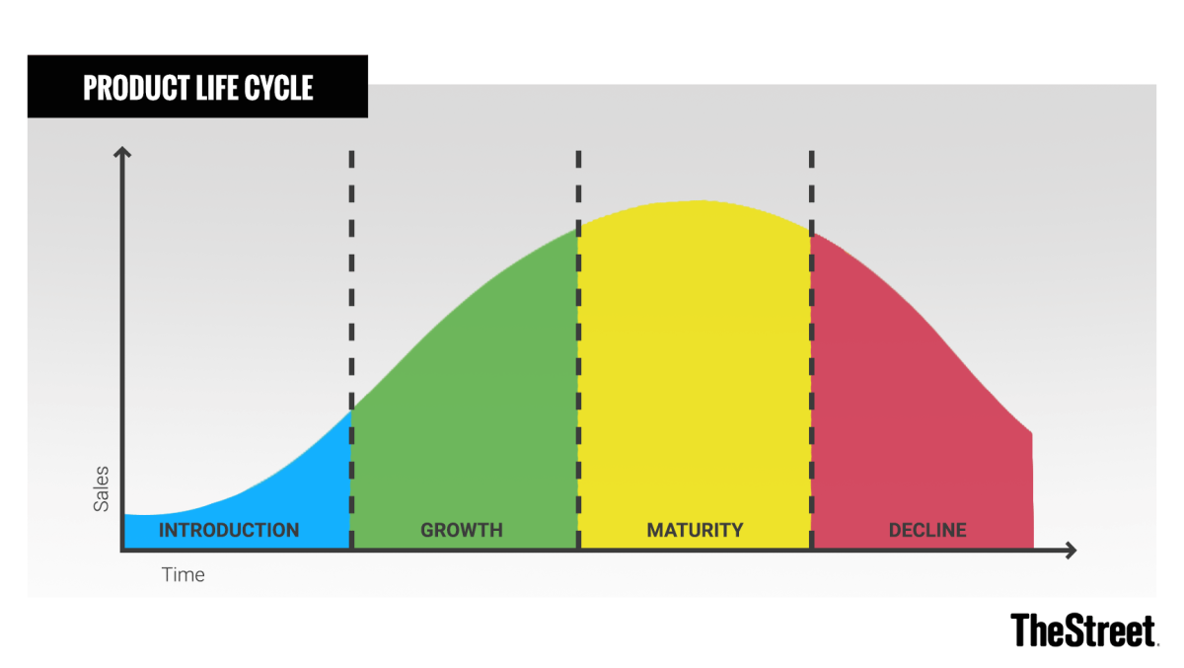

Normally Product life cycle is divided into these four stages:

1. Introduction
2. Growth
3. Maturity
4. Decline

This concept is used by management and by marketing professionals as a factor in deciding when it is appropriate to increase advertising, reduce prices, expand to new markets, or redesign packaging.

But As you know it’s a digital product and these products were lasted for years and life time. But when our client feels that there product is now became old and he feels glitches and bugs and their performance were not that good and it does not support new features which were in in market then our maintenance engineers were start working on that software at the backend and they send new updates in which they fix their bugs, glitches and improve their performance and add extra features in that update and that the same old, buggy , old version software were totally transformed into a new product. In fact, the maintenance were always running at the backend of the software to make that product in a running position. Actually these digital product were never became old a single update were totally changed its interface. But one serious problem with these digital products is that the hackers were always find opportunity to attack on their database or hijack that product but we also provide security assurance to these products and that’s how our digital product were lasted life time without any hurdles. This is how we enhance product life cycle.